Landing Page:
- Scrolling does not work:
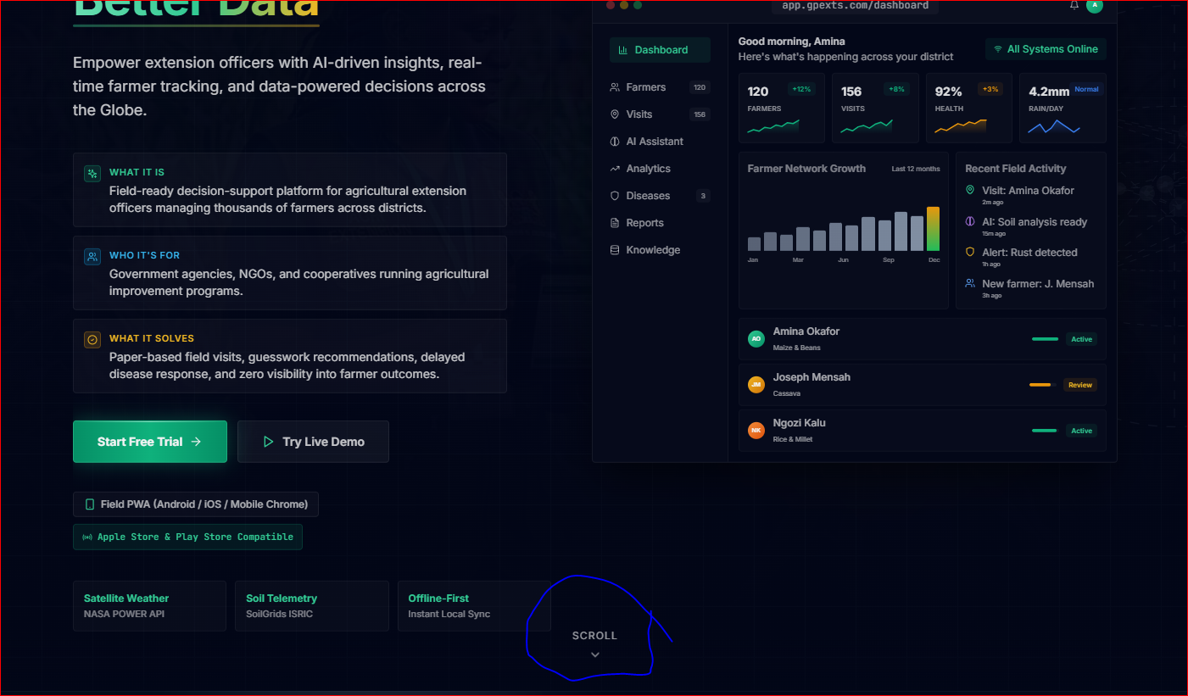
- Chat Bot Text does not work. It does not matter how simple a question/prompt is, it will always take about 30 seconds to load and at the end it will reply: “How can I help you today?”. See below:
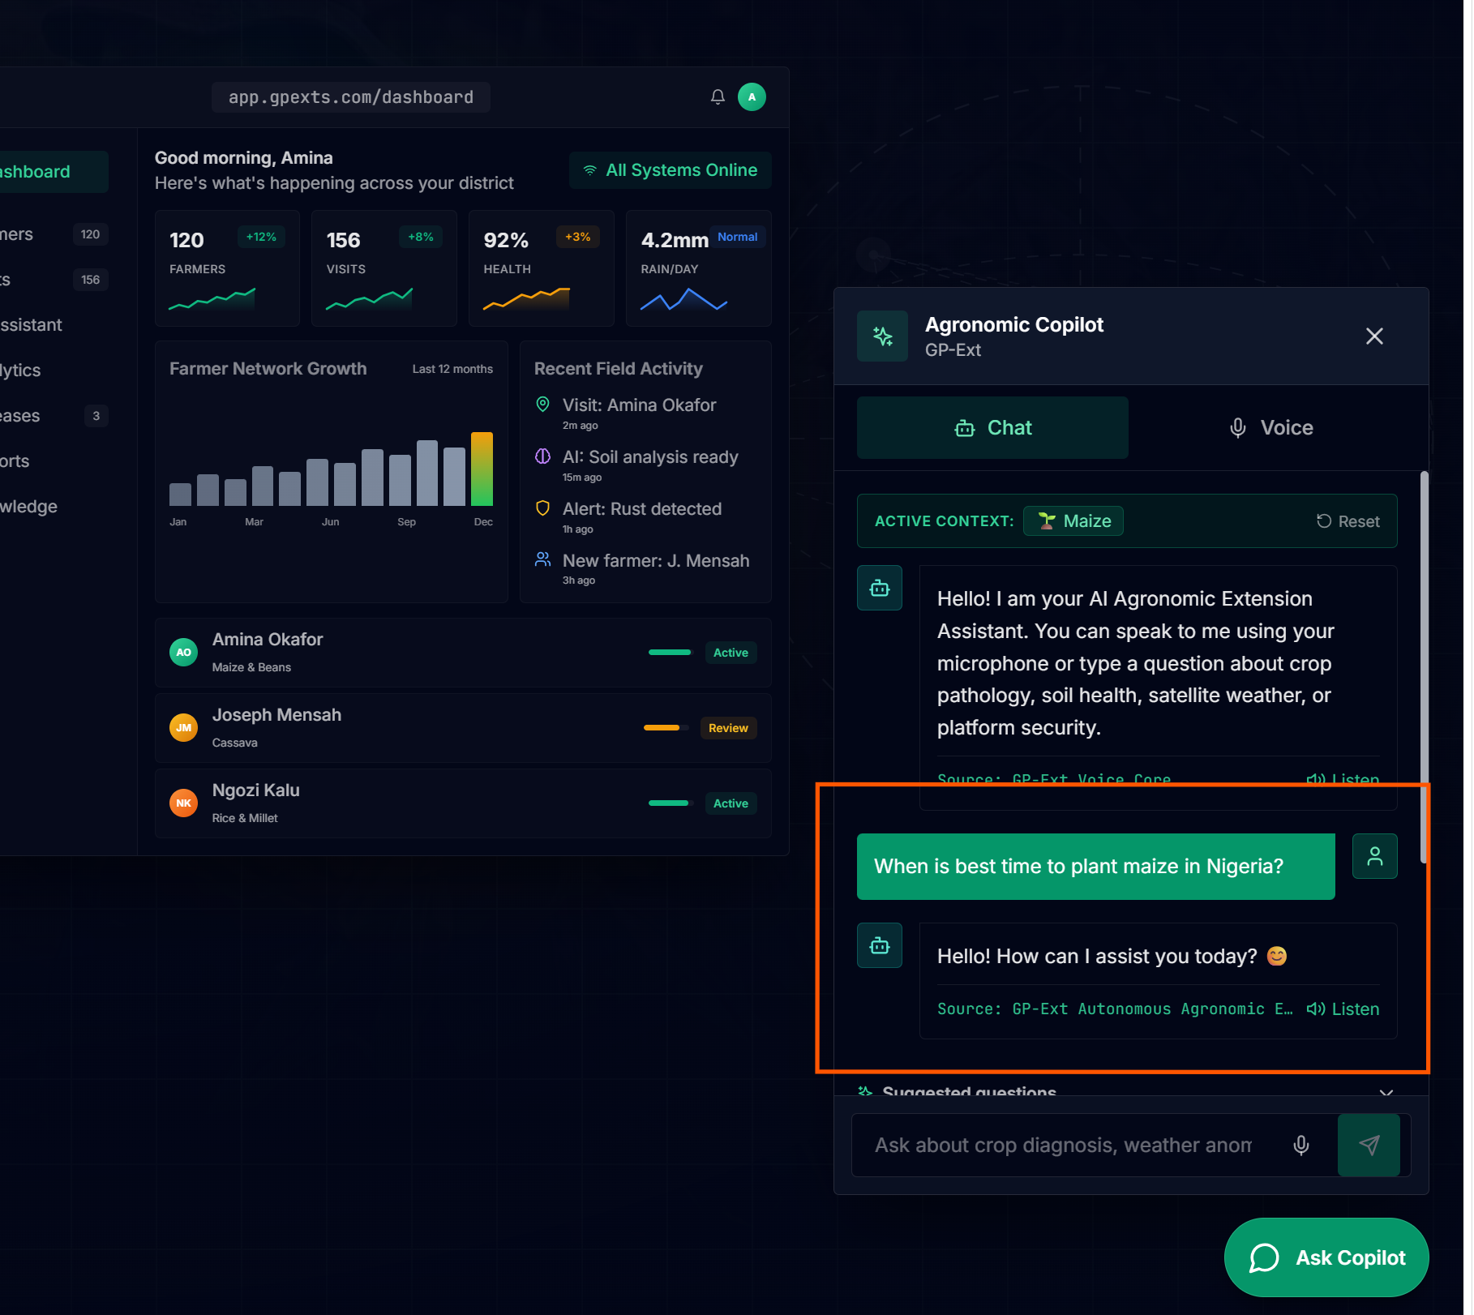
3. Chat Speak does not work. By activating speaker and talking, nothing is recorded and there is no feedback or answer.

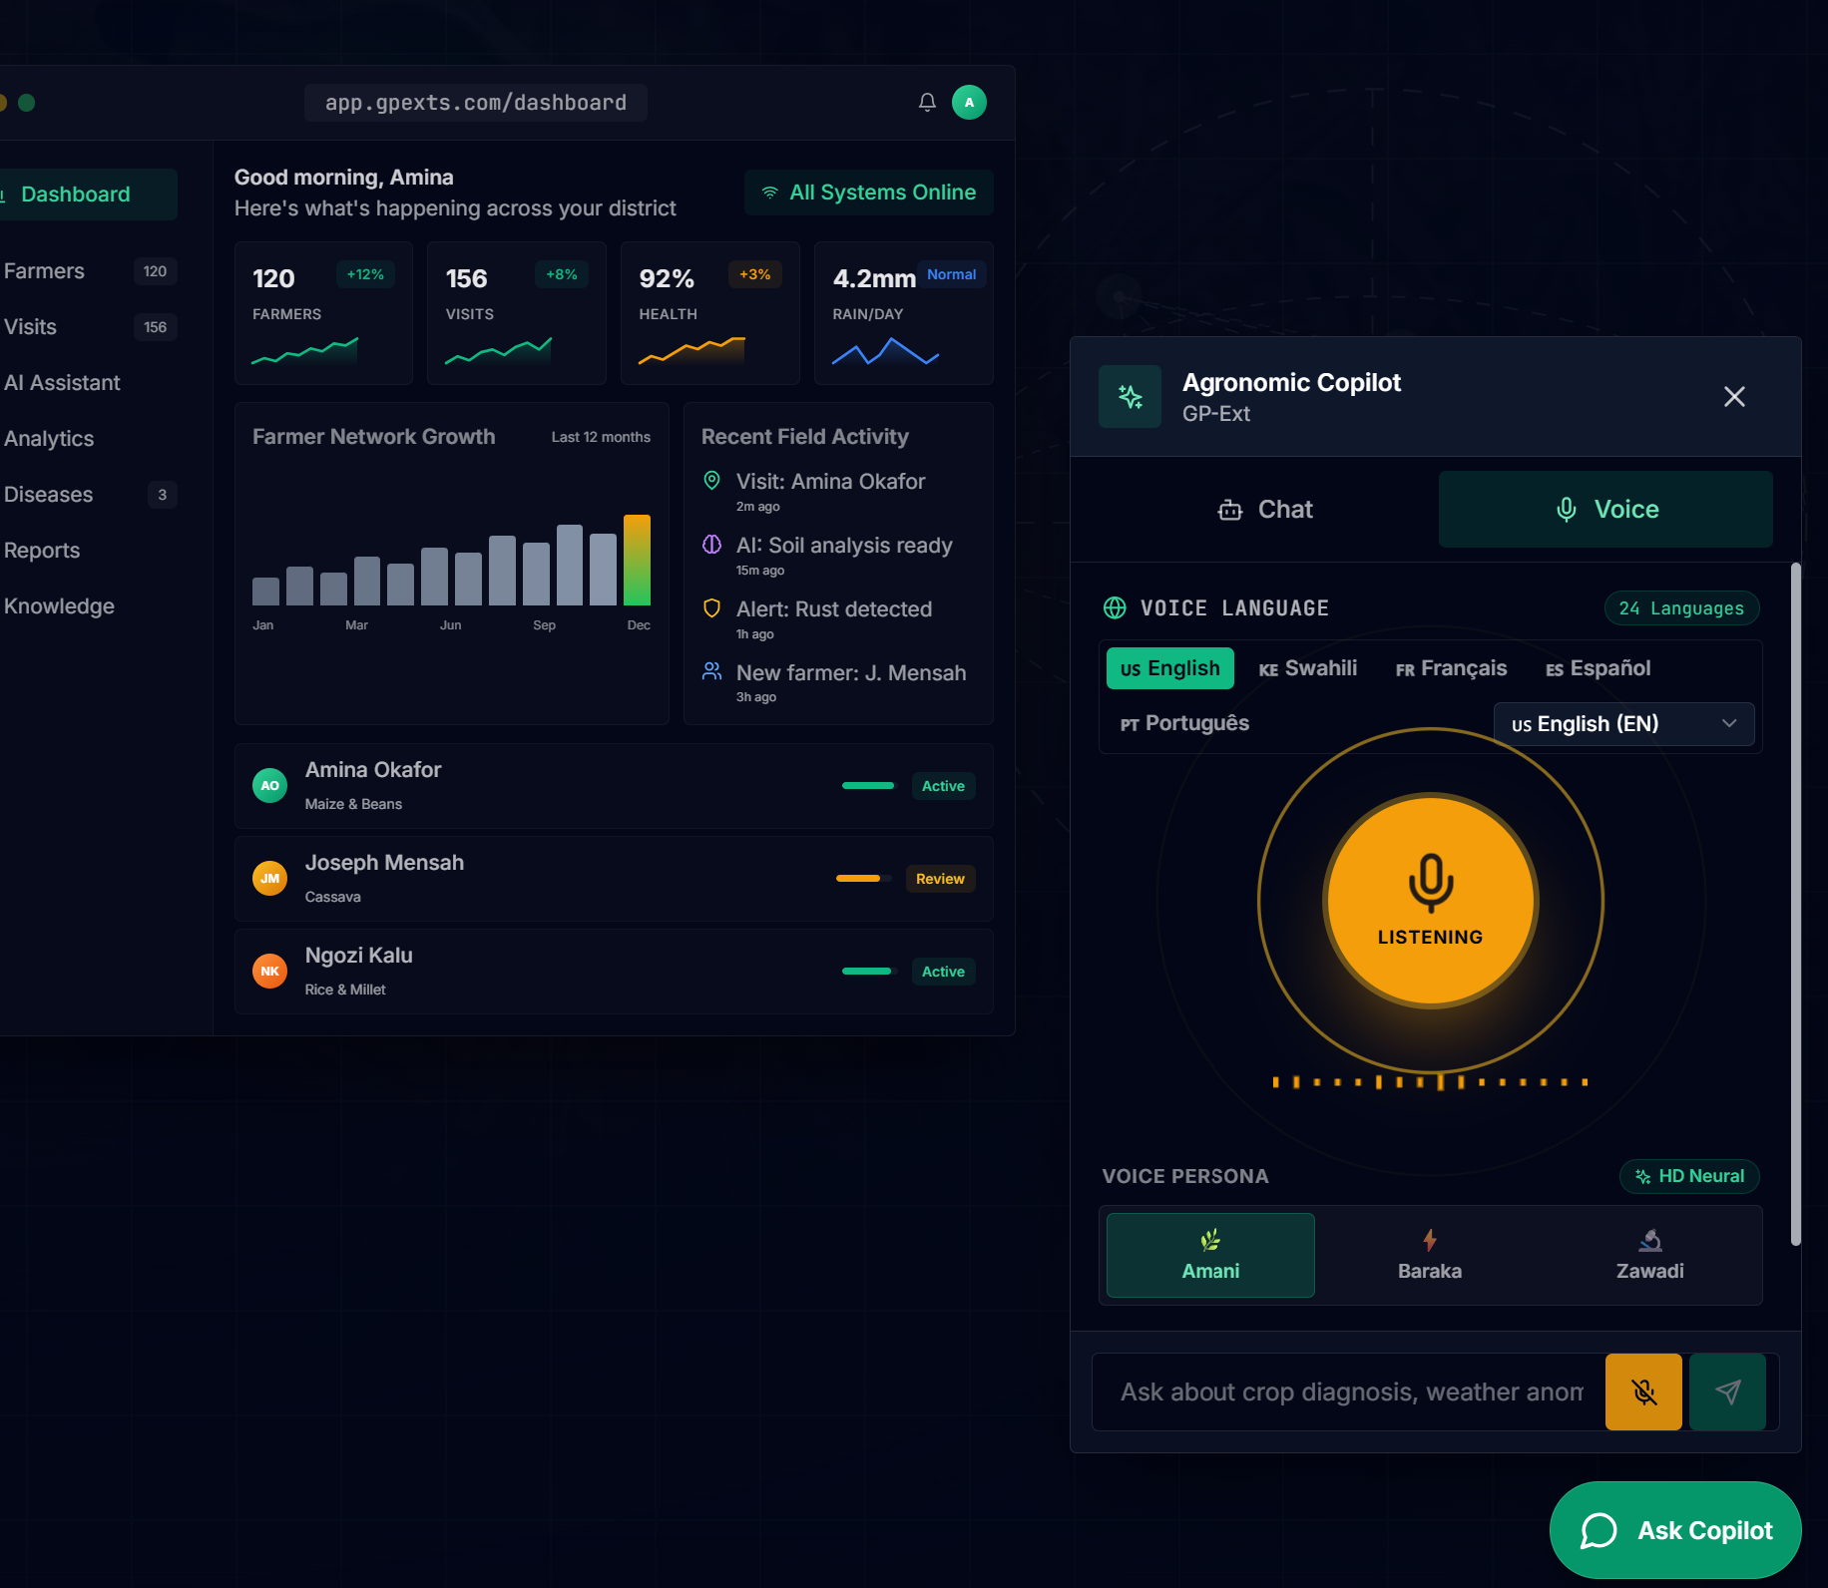
4. This feature is still active or it was reactivated? Users might mistakenly activate it and may not know how to get out of it. Since this effect does not have a benefit for this platform, I would still recommend we deactivate it completely
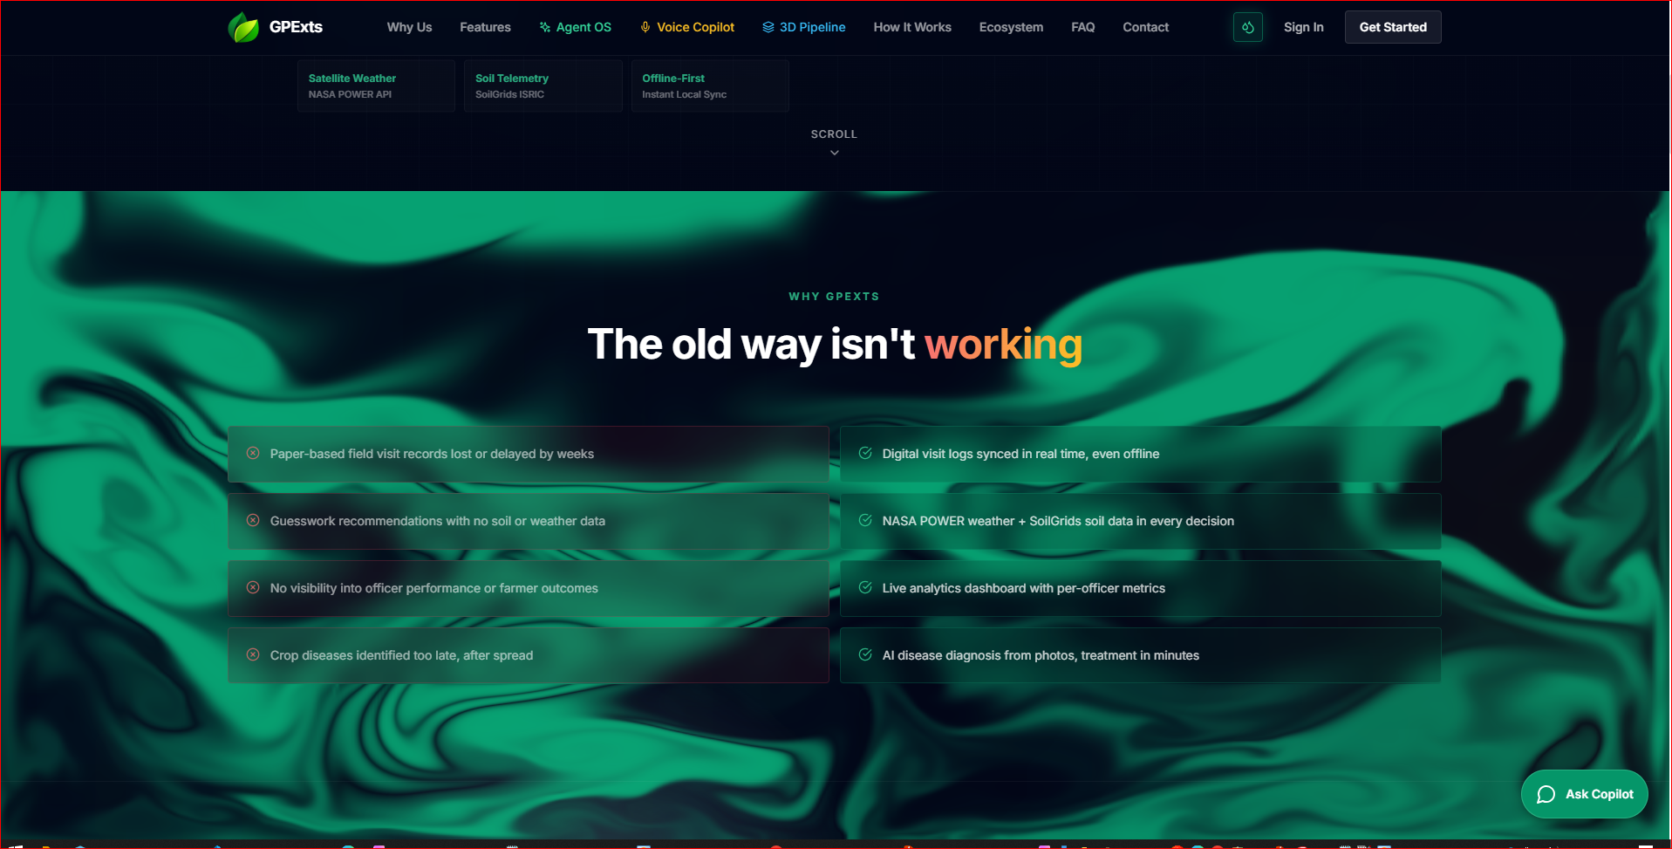

5. We do not have the option highlighted yet, so we should not enable this details on the landing page:
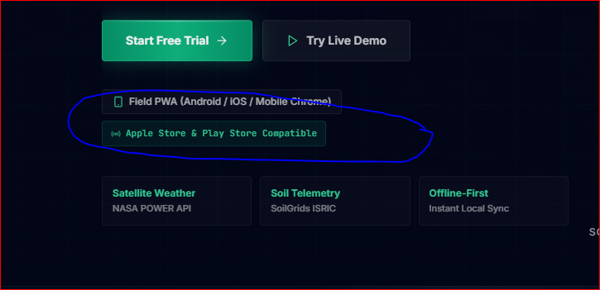

Demo Page:
- The “Play Recorded Note” function does not work
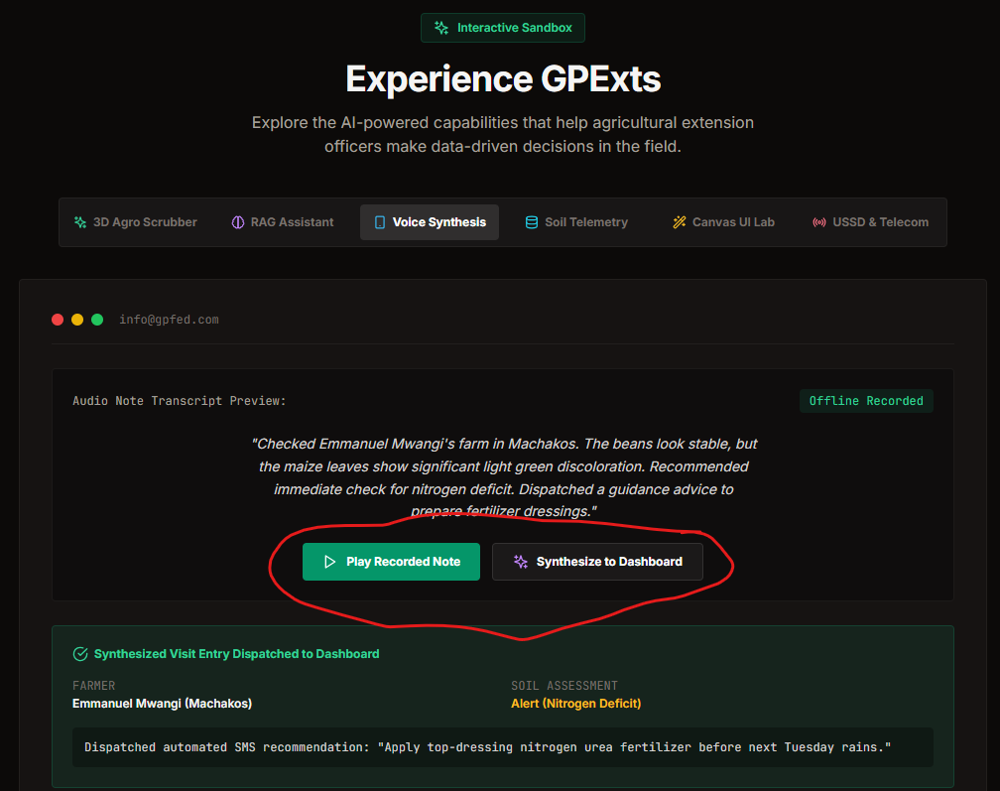
2. The pricing system has not been finalized, so this has to be hiding for now:
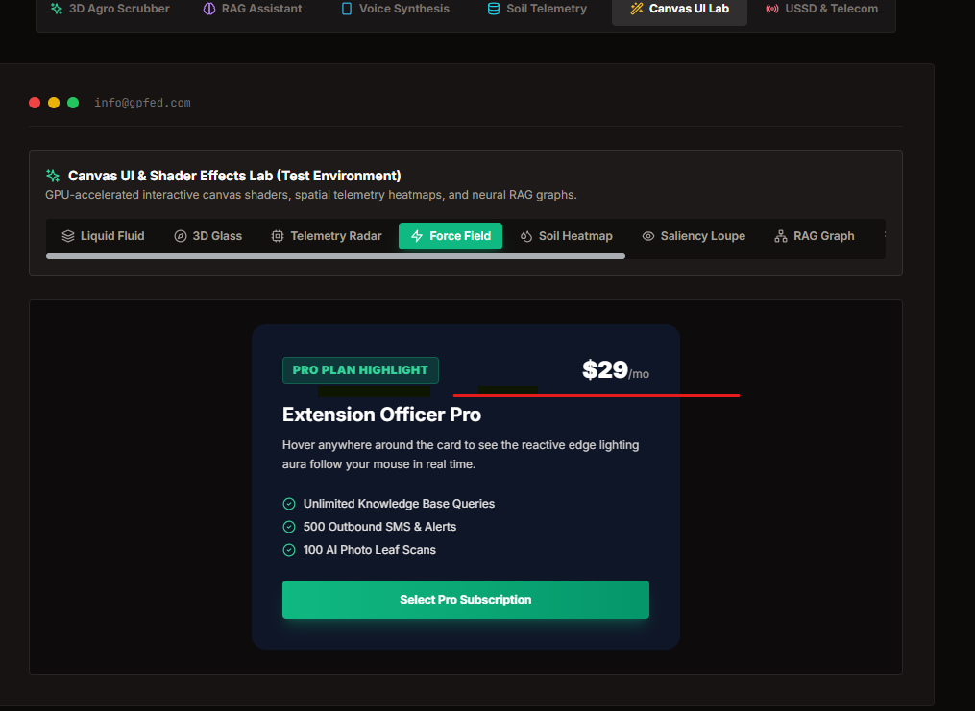
3. The “Canvas UI Lab” tab is irrelevant for demo page. It is more of graphic design/gaming-ish rather than to present the functionalities farmers will seek or need. 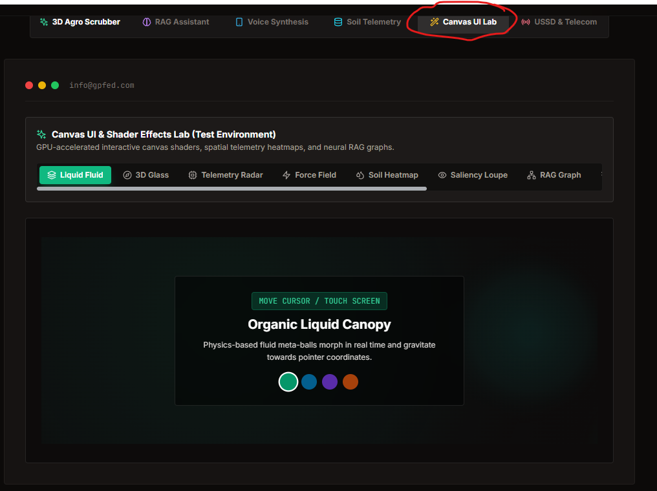

Register and Login pages:
- Task: There is no way to get back to the landing page from both Register and Login pages. They are dead ends. Only possible when users retypes the URL or click on saved link.
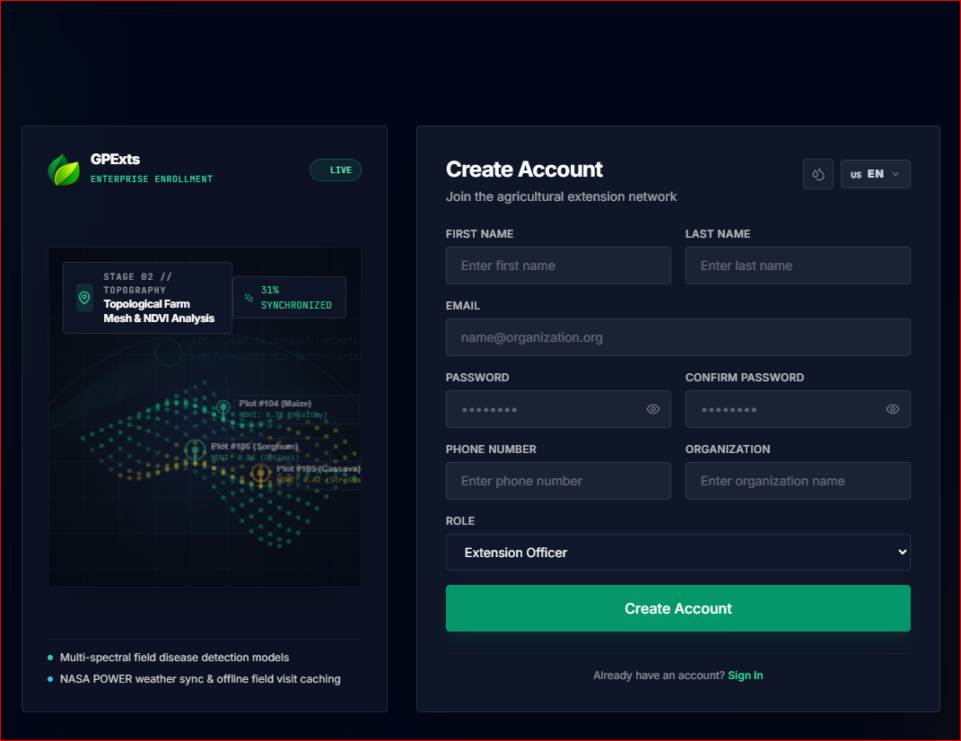
However, the Login to Demo page has the link (marked section of image below):

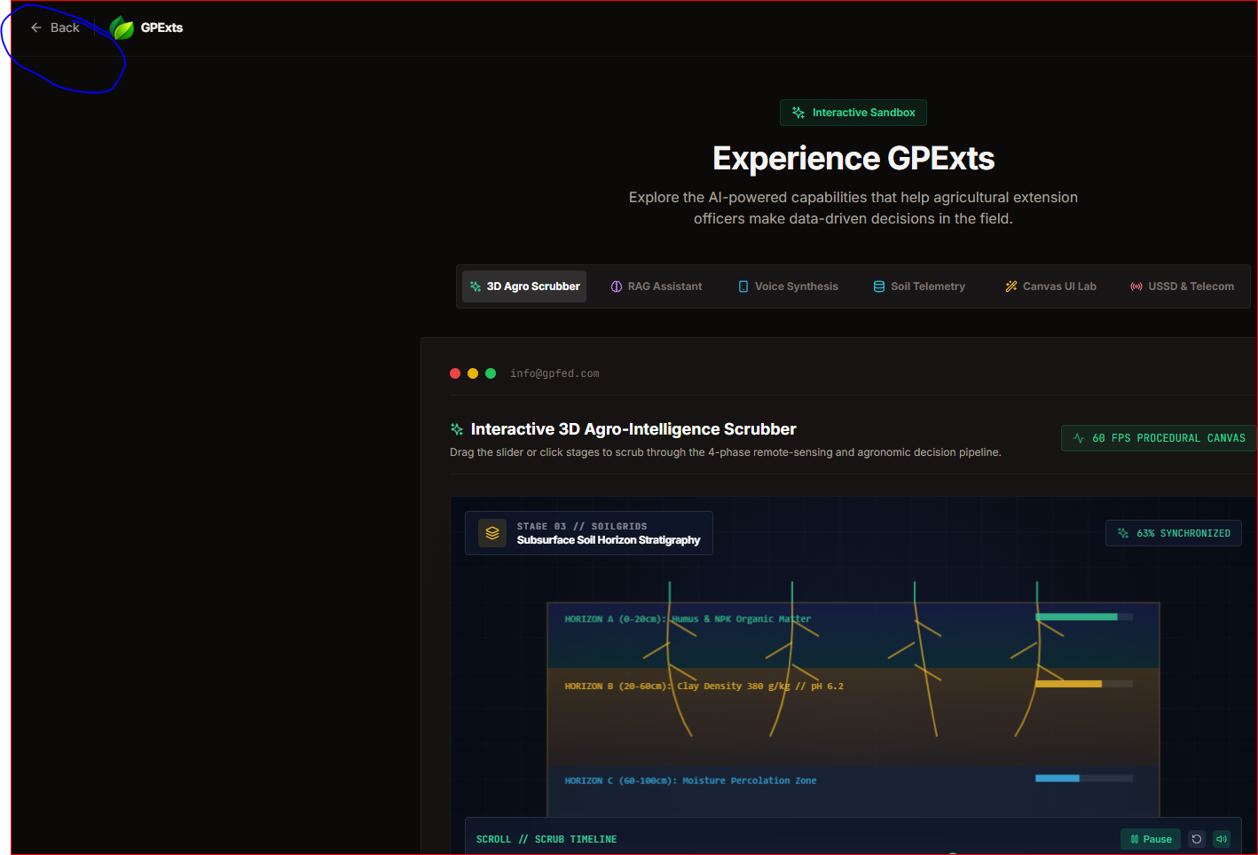

APP Pages

Dashboard Page
1. Overlapping of Chat & Install App:

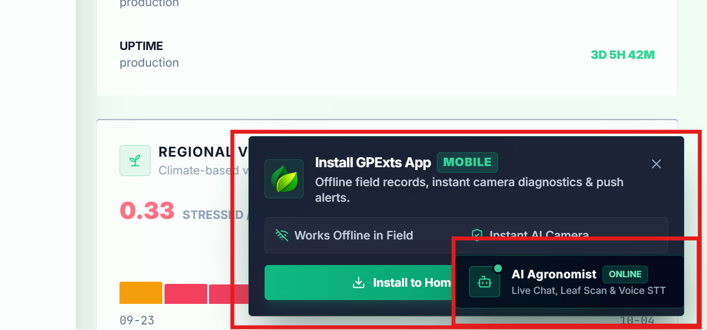

2. We can not sell what is openly available for everyone on the internet. We can not also reveal such secrets to everyone. Gemini & Ollama models used for knowledge base are clearly shown in the chat popup:
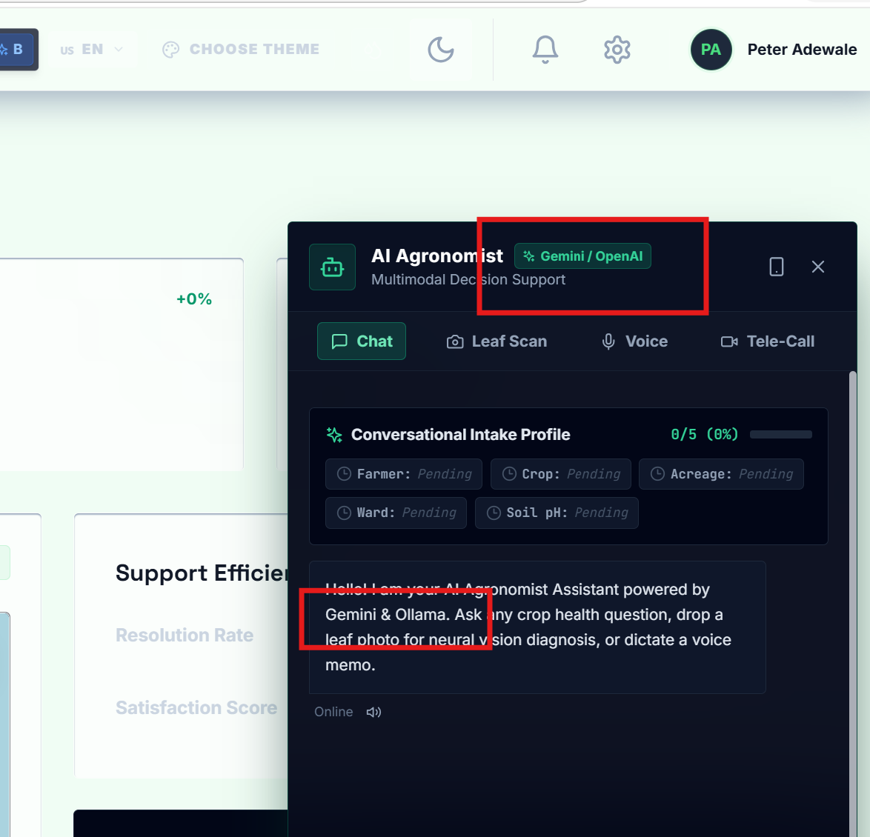

3. Random display of unwanted information: when a user clicks on the chat field to type a prompt, the red-marked info usually pops up automatically and randomly
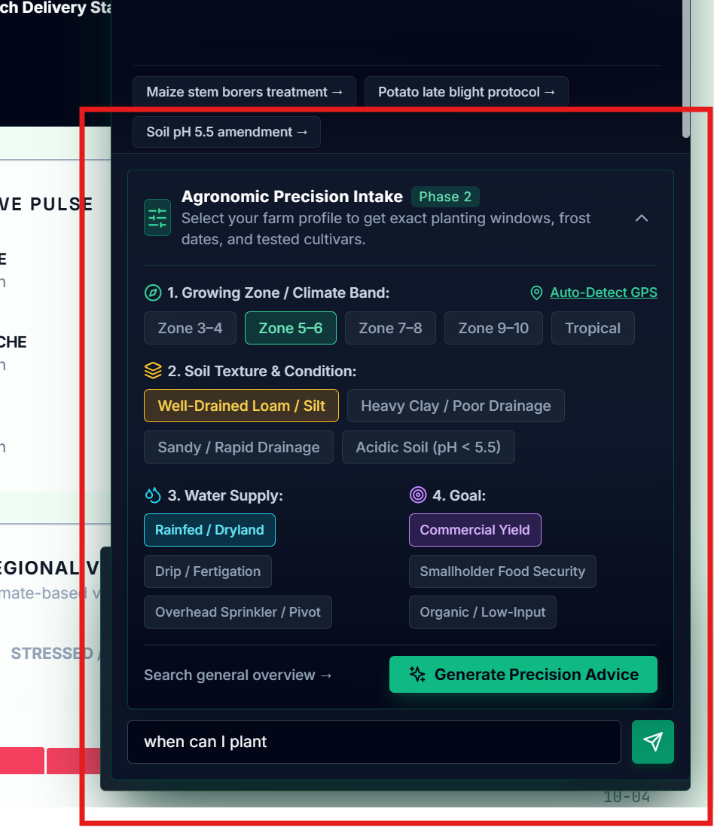

4. The chat is not providing any results to basic questions yet. Example in the screenshot. I should not be always referred to the Extension officers for simple questions.
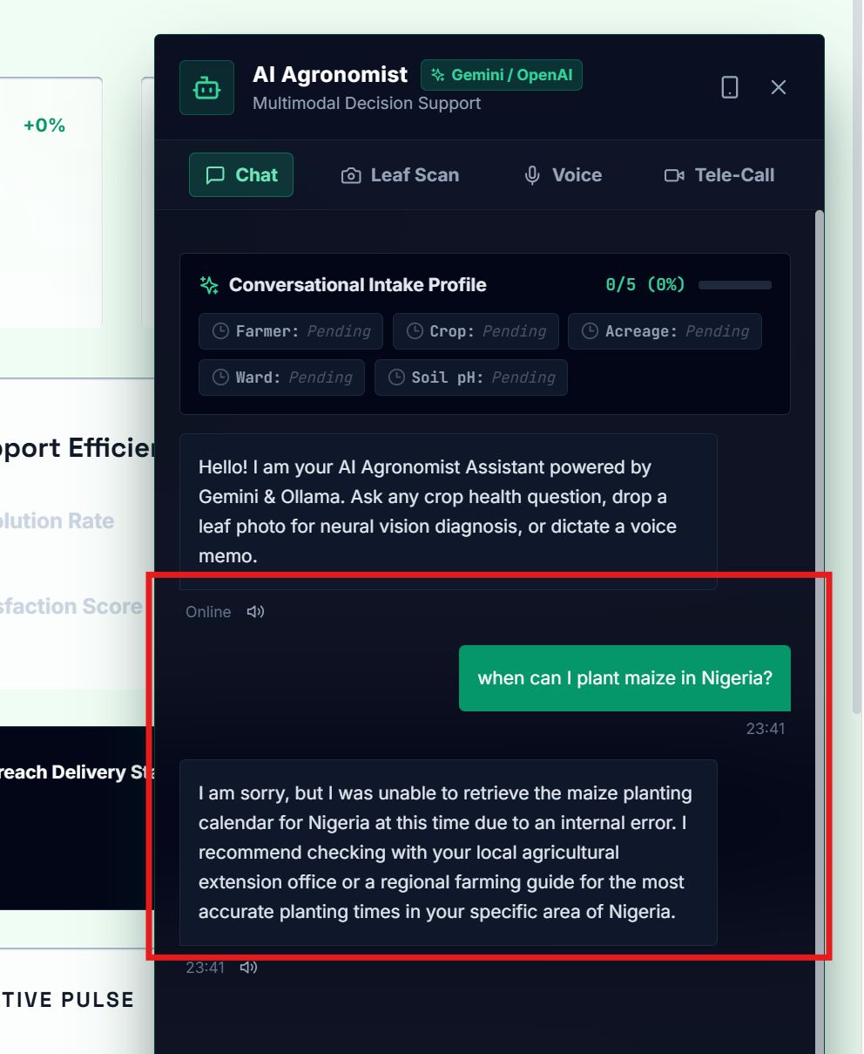

5. No way to clear current chat or history or to start a new chat. This option is necessary so that conversations of different topics will not be mixed up. Users should have options of what to do with the chat and the chat history
6. The chat does not retain the conversation. If a user refreshes a page, the whole conversation is automatically wiped out. No recovery.
7. Invisible text in most fields. When users type in the field, they will not see what they type (only when the highlight the invisible before the text can be revealed). Example is the profile popup page below. The right image is highlighted but the left not, even though the text is there the whole time:
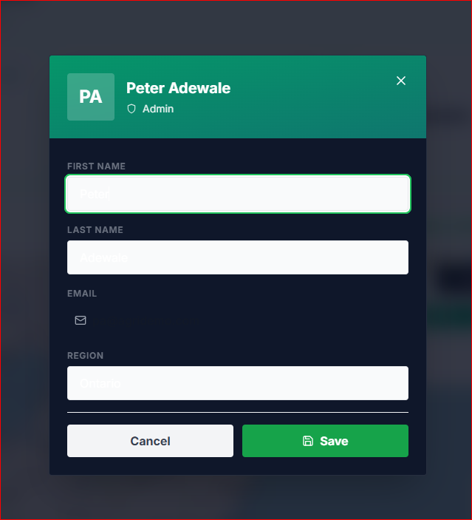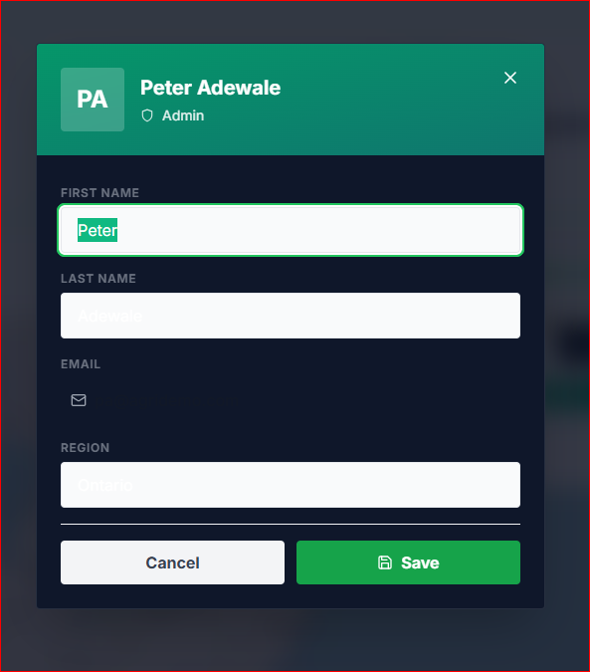

8. The design preferences on the setting on landing page does not show any difference. The same with the A/B Test on the landing page. See both images:

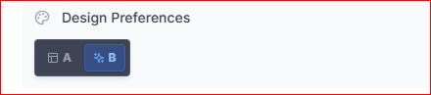


9. Language issue. The only language that is complete is English. Other languages are mixture of different languages. When a user switches language, the switch works but most pages still have English expression and mixtures of other languages. I think language was implemented BEFORE some other addition of features but the language was no more reworked. Example of such case are below. Highlight 1. Is the evidence of the current language; 2. Is the language expected; 3. Is the English mixture in the same page:
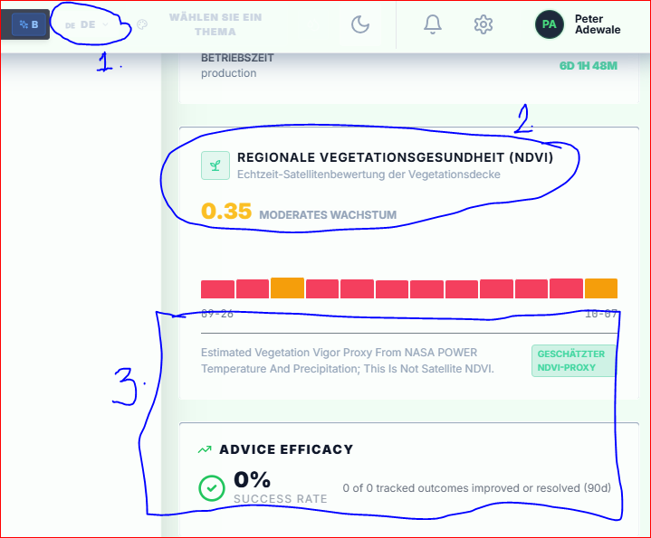

10. Some text do not fit in the space. Also,language switch make the text sizes of the sidebar longer, so many words would not fit any longer. See the images in two different languages. My suggestion is to shorting long words and use simple words when possible so that the translated words can be short too to contain everything in a small space of the sidebar.

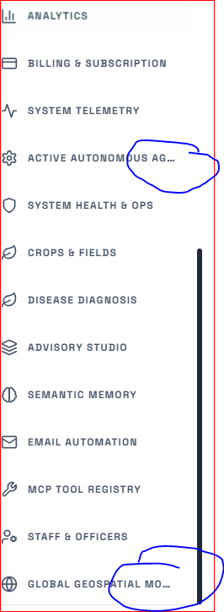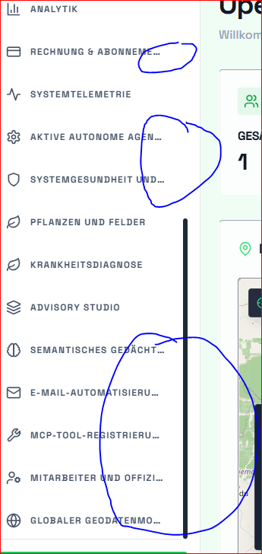

11. Search function doe not work:
There is a drop-down when user is typing but no suggested answer populates the field.
Secondly, it is transparent that it blends with the background. Nobody can see text clearly without having to highlight.
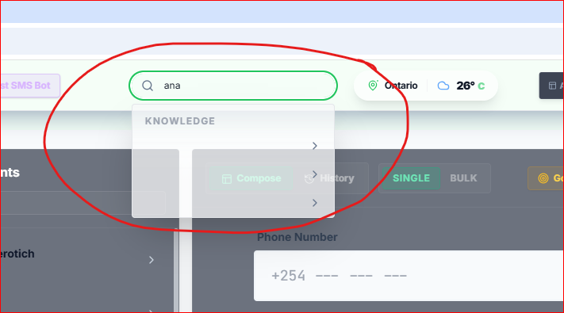

12. The same effect is implemented in the app pages too. I think we can disable it. Its button is hardly seen in the light mode, but visible in the dark mode.
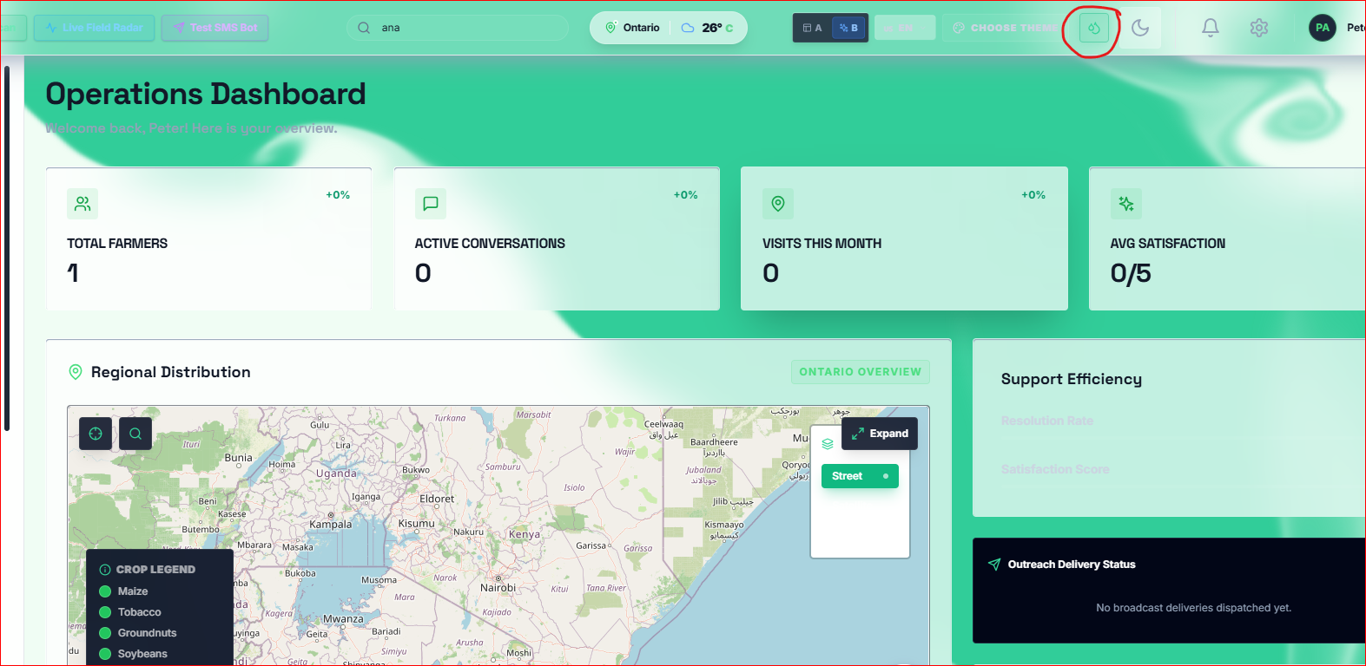

13. Map update by Location Allowance: Can we automatically update users location if they already accept to use their locations? Currently, after the user accepts location to be used (as marked 1.), the location text changes (as marked 2.). But if the precise location icon (as marked 3.) is not clicked again, the map will not reload (as marked 4.)
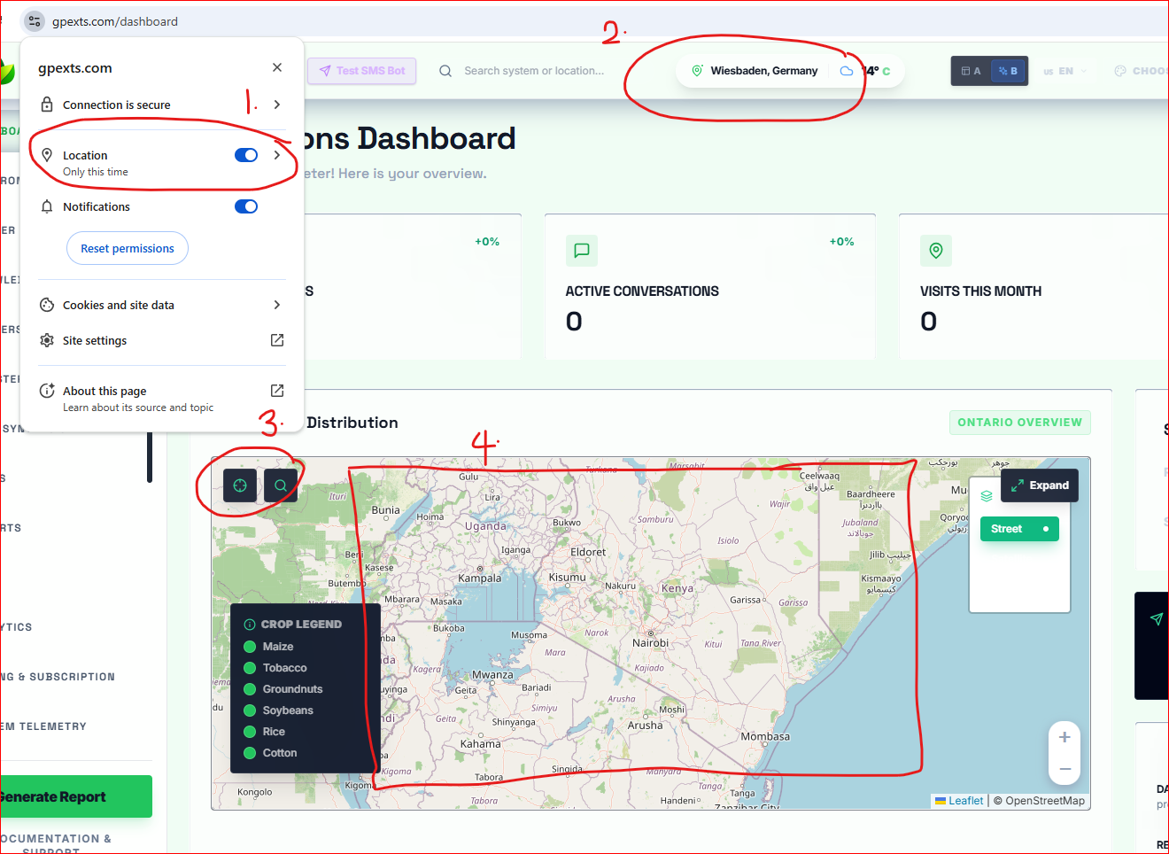

14. Regional Distribution needs a rework. The location does not completely update even when it is permitted to use precise location. Sometimes the app has two locations simultaneously. See the marked locations below (Ontario & Wiesbaden Germany the same time):
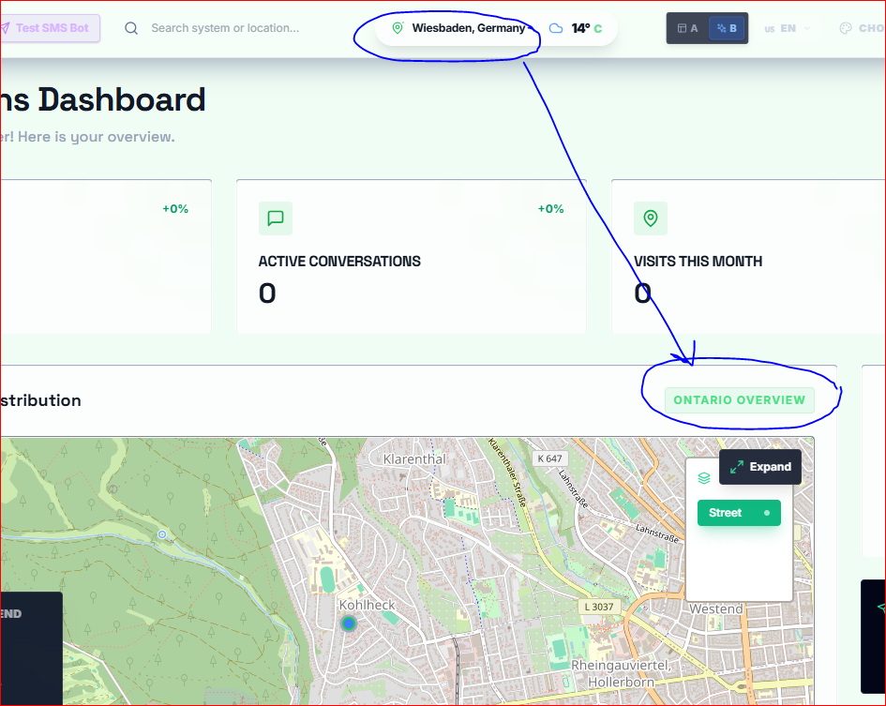

15. Redundancies: On the sidebar there are function/pages we could easily combine to remove redundancies. It will reduce the complexity of the app and code. For example, the following are marked in the screenshot should be on the same page but can be categorized by tabs:
- Both Reports and Generate Reports
- Farmers and Register Farmers
- Etc.

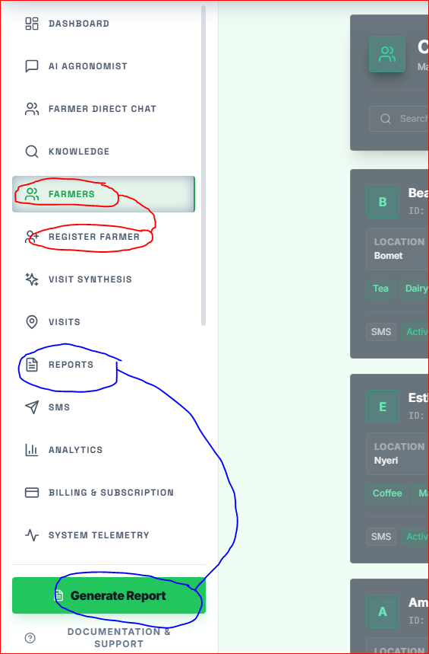

16. Help page is invisible. There is nothing any user can see on the page. The only way to see anything is to mouse-highlight. Note: this is when the app is in Light mode. In Dark mode the text is visible.
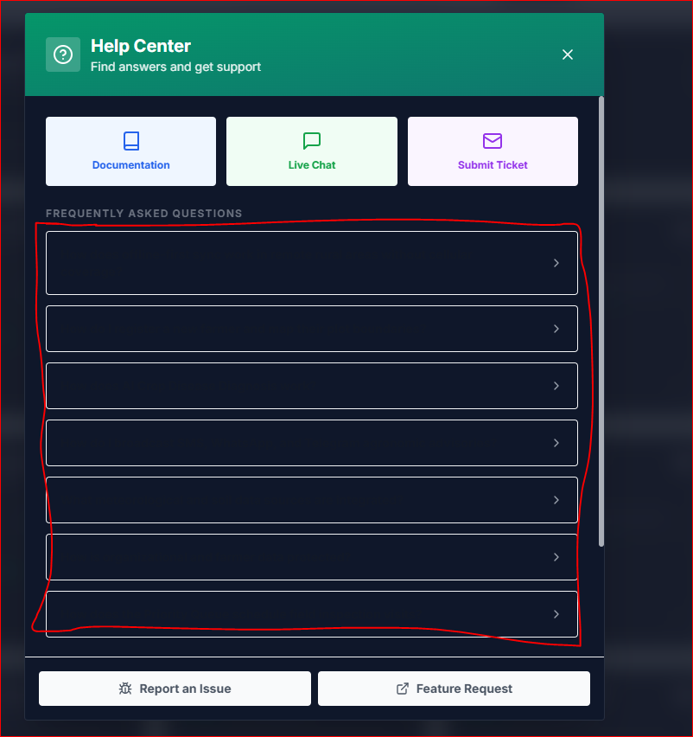

17. Bug Report card is not working. None of the categories selected is reacting. No error message, no response, clicking does not react or respond.
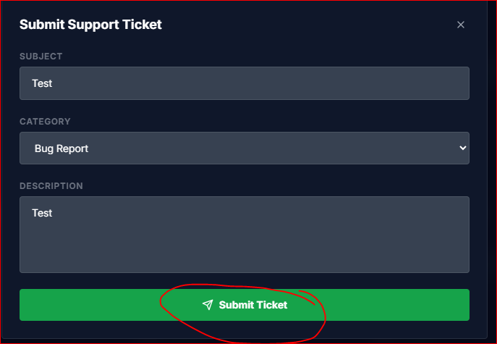
None of these works:
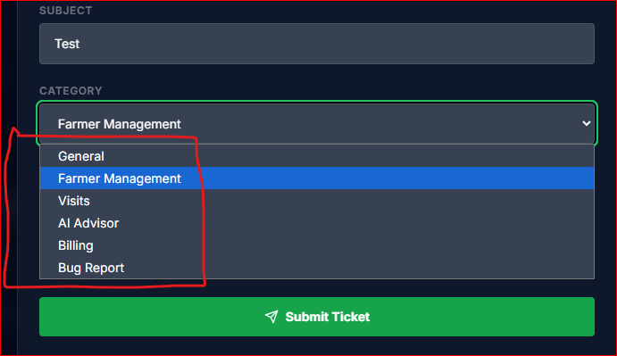
18. Dead link in the Documentation part of the Help center. When users click on it, they are not redirected but instead, the page will just close
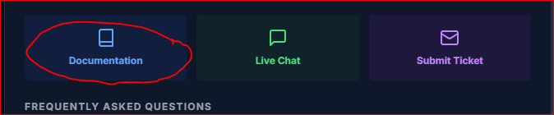

19. There is also a redundancy here because both button beside each other lead to the same page, though they meant different things:
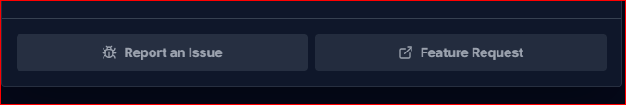

20. Poor text visibility in Light mode in all pages! Screenshots are just examples. Only bold font can be possibly seen. A rework is required in ALL pages

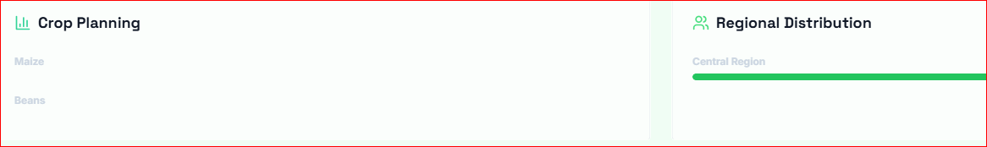
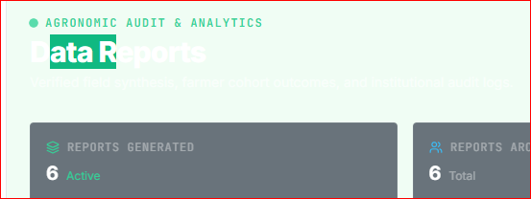
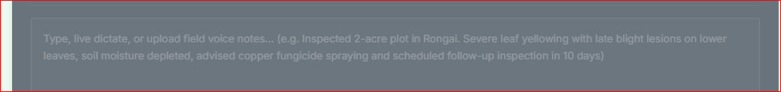
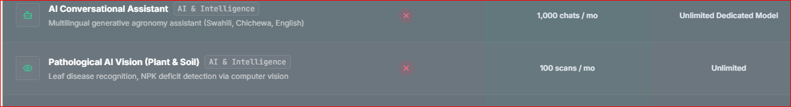

21. Half (or about 40%) of the Dashboard page is empty! Content is only arranged in right corner while nothing occupies the main area most important to display Dashboard information
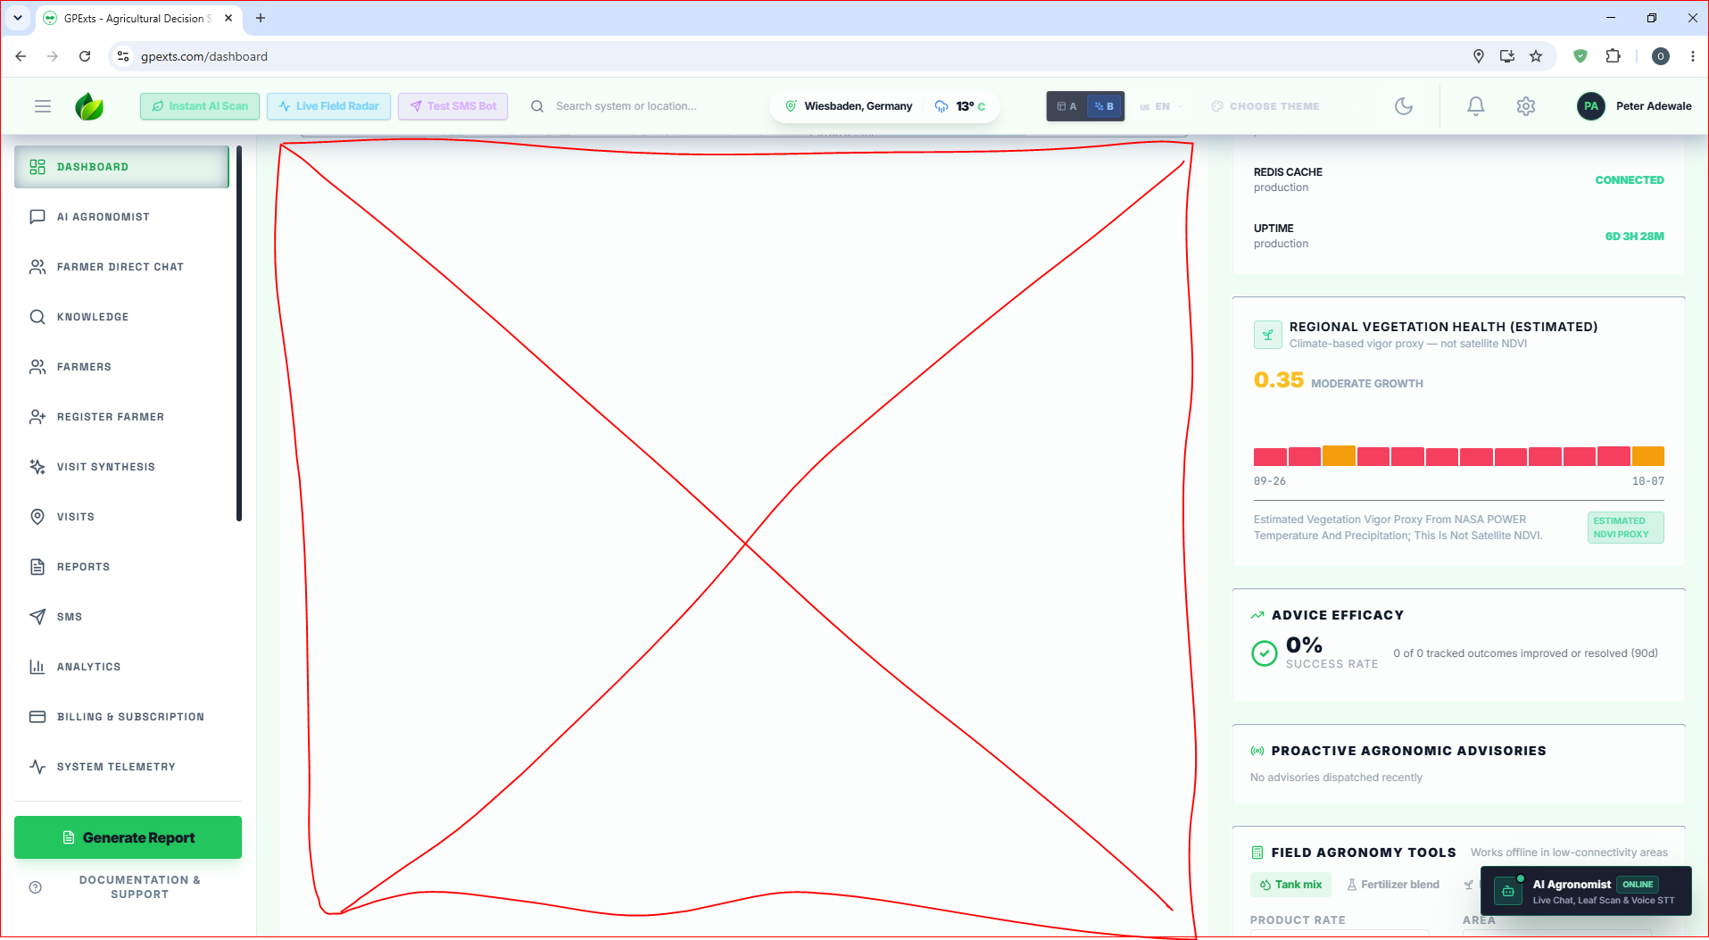
22. Those two circled buttons do not do anything. If it would be used later we can either:
- Hide them for now
- Complete their implementation
- Populate their returns with demo data/info for users to know what they are for or how they work
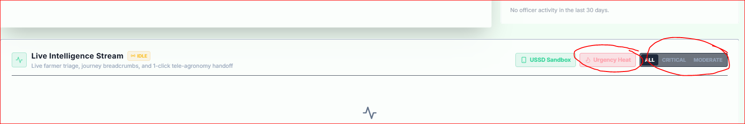
23. Though not a bug, but an enhancement request: can we implement user avatar option? It increase user experience and provides engagement benefits. Apart from major functionalities of app, enhanced experience & Personalization (Sense of Ownership) gives the app a plus to all users.
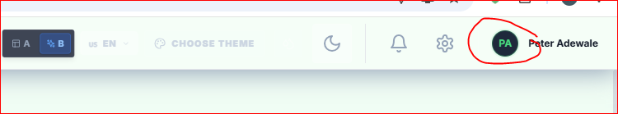

24. Profile page contains only user name and email address. Enhancement and optimizations are needed. I would suggest more stuff like:
- Manage Preference
- Password change option
- Username assignment option
- Ability for users to delete their account/profile
- Notification Setting (user specific)
- Privacy & Security Settings
- User Type or role
- Etc.
25. Since we are not using real user or farm data for now, I propose we populate a lot of empty regions that are waiting for real data for now. They will show the intenetion of the design instead of be empty.

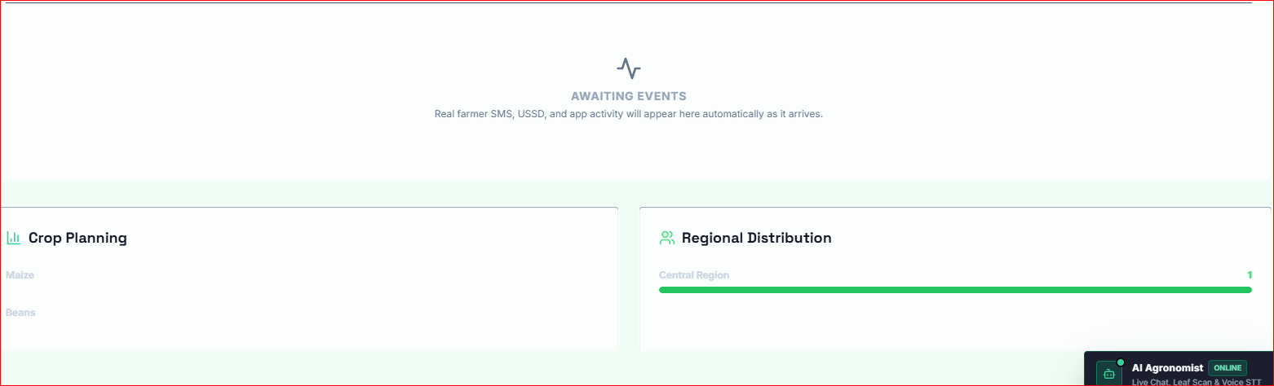

26. Though the farmers are in the list, users can not search them in the map search bar.
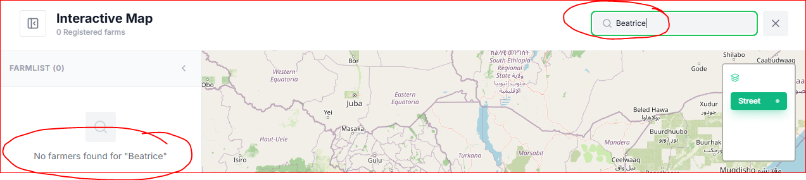

27. Additional view is available but not responding. This has once worked fine before. I think subsequent deployment broke that functionality. We should either fix it or remove the button since it is just “nice to have” feature, not a must have.
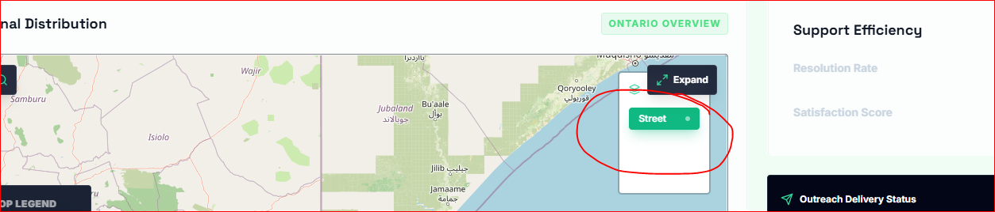

28. The cards on Dashboard are too large for their information they provide. This gives away a lot of space on the page. We can reduce them and use the saved space for some of the suggested enhancement I made down below
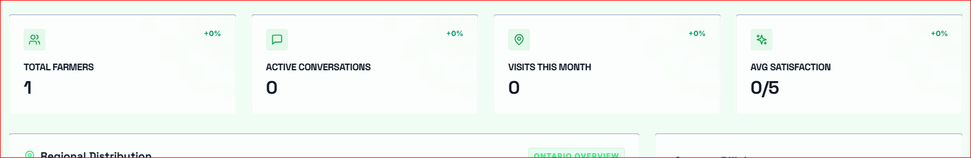

29. Does this pulse mean that the whole app is active or that the database is active? If it is about the whole data, I would suggest we relocate it to the main upper part of the dashboard for easy visibility and better UX.
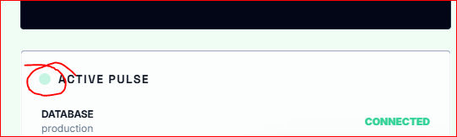
30. There are 25 items on sidebar! We need to find a way to reduce them by:
- merging similar items?
- Creating them as tabs in one page?
- Etc.?

——————————————————————————————————————————

Upgrade/Suggestions to the Dashboard
Thoughts about the Dashboard upgrades: Because the app is tailored for extension officers working in the field (often with poor connectivity), the dashboard layout needs to be highly action-oriented, data-driven, and offline-resilient.
I think more of suggesting more modules, widgets, and content types like below. They can be dynamic according who logs in, meaning the Extension Officer Dashboard may have more info than other users in their Dashboard:
- An Icon for a New message/chat text from another farmer so that they can easily see when they get a new message or info from another.
- Active Alerts / Flagged Farms: A dynamic badge indicating farms experiencing active disease outbreaks, severe weather, or soil deficiencies. I might be wrong but I think there should be Color-Coded Status symbols: Pins indicating farm health (Green: Stable, Yellow: Action Required, Red: Alert/Disease).
- Field Task Manager & Activity Hub (for Extension officer users?)
- Climate & Soil Intelligence: A multi-day forecast powered by satellite data tracking rainfall probability, temperature, and wind speed.
- Soil Telemetry Feed: Real-time data displaying moisture levels, soil composition data, and localized nutrient deficiencies mapped directly from regional telemetry.
- AI-Driven Advisor & Decision Support shortcut (AI Recommendation Console or shortcut): Like a kind of predictive widget that inputs current crop types, weather, and soil telemetry to auto-generate recommended actions for farmers.
- Pest & Disease Diagnosis Shortcut: A quick-launch camera tool that uses AI to scan a crop leaf, diagnose potential issues, and suggest an immediate response plan.
- Sync Status & Core Functionality: Offline Status Indicator: A persistent, highly visible badge verifying that data is locally saved (e.g., "Offline Mode Active - 12 Pending Syncs"). Instant Local Sync Button: A manual trigger button that updates local telemetry records as soon as internet connectivity is detected.
- Farmer Reach Counter: Total active farmers managed by the officer in the current district.
- Active Farm / Zone Selector: A quick dropdown or swipeable card to switch between different agricultural sites or crop fields.
There is a lot of space we can make use of in the dashboard. Let us reconsider some more features while we keep the page not congested.

